M=BUS LAB Analog Board
Stationary data logger for signal conditioning, processing and data storage of analog signals. |  |  |  | 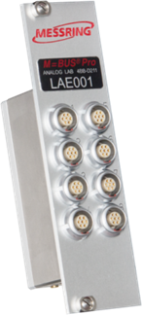
- Data logger/board for 8 analog channels
- 16 bit resolution
- Max. 500 kHz sampling rate
- Internal shunt resistor
- Internal bridge completion

TECHNICAL SPECIFICATIONS
Supported channels |  |  |  | 8
Power consumption (unloaded) |  |  |  | 2.7 W
Supported instrumentation |  |  |  | Resistive sensors / active sensors
Sensor excitation voltage |  |  |  | 5 VDC
Accuracy of sensor excitation voltage |  |  |  | 0.1 %
Max. output current per channel |  |  |  | 30 mA
Sensor input voltage |  |  |  | ± 1.25 mV…± 2.5 V  (over voltage protection up to ± 48 V)
High voltage measurement |  |  |  | ± 50 V (over voltage protection up to ± 150 V)
Trigger |  |  |  | M=BUS system trigger via gateway
Conformity |  |  |  | SAE J211 / ISO 6487
Analog bandwidth (- 3 dB) |  |  |  | >60 kHz @ gain 2,000
Resolution |  |  |  | 16 bit
Sampling rate |  |  |  | 20 kHz / 100 kHz / 500 kHz
Max. recording time |  |  |  | 3.2 h per channel @ 20 kHz  (233,963,520 samples per channel)
Internal shunt |  |  |  | Yes (20 kΩ 0.1%)
Internal bridge completion |  |  |  | Half bridge
Offset adjustment |  |  |  | Full range sensor input voltage, 16 bit
Sensor-ID per socket |  |  |  | 1-Wire® compatible (Dallas)
Data storage |  |  |  | 4 GB flash
Data storage time |  |  |  | Non-volatile
Dimensions |  |  |  | 1 slot
Weight |  |  |  | 222 g
M=BUS connectors |  |  |  | MMCX female
Operating temperature |  |  |  | 0…50°C
Humidity range |  |  |  | 10...70 % RH
Scope of supply |  |  |  | - M=BUS LAB Analog Board  - M=BUS system cable (300 mm)  - Calibration certificate
Required equipment |  |  |  | - M=BUS LAB Base Unit (USB or Ethernet with instrument housing)
PIN ASSIGNMENT
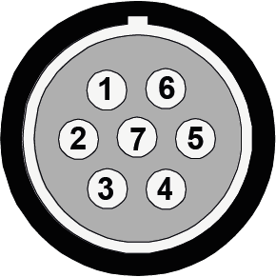 | Pin |  | Description |  | Pin | Description
 | 1 |  | Not connected |  | 5 | Negative excitation (GND)
 | 2 |  | ID-module |  | 6 | Negative sensor input
 | 3 |  | Positive sensor input |  | 7 | -50...50 V input
 | 4 |  | Positive excitation (5 V)
 | Socket housing connected to ground
Figure 1: (MESSRING product code 4BBD211) Standard pin assignment (socket view, device)
Use this plug: LEMO FGG.1B.307...
 | Pin | Description |  |  | Pin | Description
 | 1 | Positive excitation (5 V) |  |  | 5 | -50...50 V input
 | 2 | Negative excitation (GND) |  |  | 6 | ID-module
 | 3 | Positive sensor input |  |  | 7 | Not connected
 | 4 | Negative sensor input
 | Socket housing connected to ground
Figure 2: (MESSRING product code 4BBD212) NA3X pin assignment (socket view, device)
Use this plug: LEMO FGG.1B.307...
Pin | Description | Pin | Description
1 | Positive sensor input | 5 | Negative excitation (GND)
2 | Positive excitation (5 V) | 6 | Negative sensor input
3 | Not connected | 7 | -50...50 V input
4 | ID-module
Socket housing connected to ground
Figure 3: (MESSRING product code 4BBD214) CP pin assignment (socket view, device)
Use this plug: LEMO FGG.1B.307...

